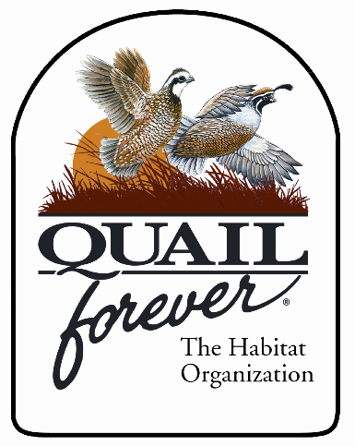
Northern KY Chapter of Quail Forever

P.O. Box 6085
Florence, KY 41022
(859)-640-0835
NKYQuailForever@yahoo.com
www.nkyquailforever.com
Northern Kentucky Quail Forever Chapter # 3198

Brian Jones – President
Mike Coyle – Treasurer / Youth Director
Jason Lett – Seed Program Director
Watson Jones – Banquet Chairman

6th Annual Banquet

July 31, 2026

Dear Friends,

The big event will be held on Friday May 10th, 2019 at Receptions Banquet Hall located at the address 1379 Donaldson Hwy Erlanger, KY. The doors will open at 6 p.m. for games and socialization with dinner being served at 7:30 p.m. Please arrive punctually to ensure your opportunity to take part in the games and to preview auction items and prizes. This year includes OPEN BAR for Beer, Wine & Well Liquor.

We are once again pre-selling banquet tickets. All orders to get in through the door need to be received by May 3rd. We will not be selling tickets after the May 3rd deadline! This will only be for tickets to get into the banquet. Tickets will not be mailed to you, but you will be signed in at the door of the hall. We will still have game tickets available at the banquet.

This year we will have 35 guns plus Live Auction, Silent Auction, & Raffle items available to win. Included is the General Raffle which includes 8 guns and other larger items, the Safe Game with a Gun Safe and 7 guns (winner takes all), & the 10 Gun Game. All three of these can be pre-ordered on the form attached or you can contact a committee member to purchase Safe Game or 10 Gun tickets. Some of these games have sold out in the past before the banquet so please contact a committee member if you are interested.

The committee members and I look forward to seeing you at the Northern KY Chapter Quail Forever Banquet on Friday May 10th!

Sincerely,
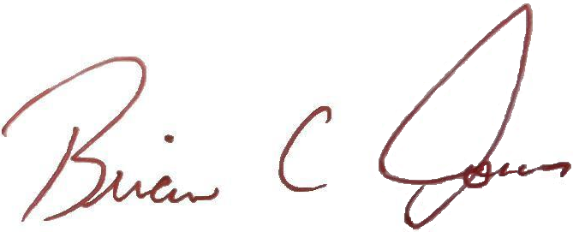
Brian C. Jones
President

*Any questions, please call the Banquet Chairman, Watson Jones, at 859-384-5200 or 859-640-0835.
NKY Chapter of Quail Forever Banquet Ticket Order Form
Mail ticket orders to:

Watson Jones
P.O. Box 6085
Florence, KY 41022

be received by May 3rd in order to come to the banquet.

Use this form to purchase banquet tickets, Raffle Packages, and pre-banquet 10 gun raffle tickets. Indicate the desired number of tickets in the blank next to each ticket option.

THIS YEAR WE HAVE AN OPEN BAR FOR BEER, WINE, & WELL LIQUOR (Cash bar for Top Shelf).

_______ Single ticket @ $75 (includes 1 membership & 1 meal)
_______ Couples ticket @ $125 (includes 1 membership & 2 meals)
_______ Sponsor ticket @ $325 (includes 1 sponsor membership, 2 meals, the sponsor’s gift, $250 in general raffle tickets, 1 chance on the hunter’s package. & a 1 in 7 chance for a $250 Glauber’s Sports Gift Certificate or sponsor gun)
_______ Youth ticket @ $40 (includes 1 meal and 1 Whistler Membership for a child age 17 & under)
_______ Economy Corporate Table @ $500 (includes 4 regular memberships and 8 meals, recognition at the banquet and one chance on corporate table gift.)
_______ Economy Corporate Plus Table @ $650 (includes 8 regular memberships, 8 meals, recognition at the banquet and one chance on corporate table gift.)
_______ Sterling Corporate Sponsor @ $800 (Includes 1 sponsor membership, 7 regular memberships, 8 meals, a reserved corporate table, one chance on corporate table gift, and recognition in the banquet program as a “Sterling Corporate Sponsor”)
_______ Gold Corporate Sponsor @ $1,300 (Includes 4 sponsor memberships, 4 regular memberships, 8 meals, a reserved corporate table, one chance on corporate table gift, and recognition in the banquet program as a “Gold Corporate Sponsor”)
_______ Platinum Corporate Sponsor @ $2,000 (Includes 8 sponsor memberships, 8 meals, a reserved corporate table, one chance on corporate table gift, and recognition in the banquet program as a “Platinum Corporate Sponsor”)
_______ Membership Only @ $35 (if you cannot attend the banquet and would like a membership)
_______ Banquet Underwriter @ $100 (pays for 7 Youth memberships, recognition at the banquet and eligibility to display the sponsored art piece during the banquet week at your place of business)
_______ General Raffle Package @ $100 (incl. a QF Hat & $200 in General Raffle Tickets)
10 Gun & Safe Raffle Tickets may be sold out before the banquet. Please purchase them in advance.

_______ 10 gun raffle ticket @ $10 (1 ticket is good for 1 chance on each of the following guns.)

- M&P 9mm Shield
- Ruger 9mm LC9S
- CZ 628 Field Select 28 GA
- Anderson AR-15 .223
- Ruger American .308
- T/C Compass 30.06
- Ruger 10/22 Take Down
- Traditions Outfitter G2 .44 Mag
- Sig Sauer 320 SC 9mm
- Stoeger M3K 12/24 12 GA

_______ Safe Game @ $50 (1 chance on a Safe & 7 guns, winner takes all. Only 200 chances sold.)

- CZ 712 – 12 GA
- Weatherby Upland 20 GA
- T/C Compass 30.06
- Ruger 10/22 Carbine
- Ruger KSP .357 Mag
- S&W SD40 VE
- S&W 22A Pistol
- Champion 20 Gun Safe

Method of payment (please check one)

___Enclosed is my check or money order in the amount of $________ payable to Quail Forever.

____I prefer to pay the total amount of __________with my: ___Visa ___MasterCard ___American Express

Credit card #_______________________________ Expiration Date ______/_______

Name:____________________________________ Security Code: _______________

Signature:_________________________________ Zip Code:____________________

Whether paying by card or check, please print the following membership information for all members (see attached sheet for multiple members). If you are purchasing a table, please list beside your personal name below the name you would like on your table (i.e. business name, group name, personal name, etc.).

Single, Couple, Sponsor, & Youth Tickets = 1 membership
Economy Corporate Table = 4 memberships
Economy Plus, Sterling, Gold, & Platinum Corporate Tables = 8 memberships

Name:___________________________________________
Address:______________________________________________________________________
City:__________________________ State:_______ Zip:__________
Phone#_________________________ E-mail ______________________________
You may also call Watson Jones at 859-384-5200 or 859-640-0835 or your friendly committee member to order tickets.

Ticket orders must be received by May 3rd if you plan to attend!

Name:___________________________________________
Address:______________________________________________________________________
City:__________________________ State:_______ Zip:__________
Phone#_________________________ E-mail ______________________________

Name:___________________________________________
Address:______________________________________________________________________
City:__________________________ State:_______ Zip:__________
Phone#_________________________ E-mail ______________________________

Name:___________________________________________
Address:______________________________________________________________________
City:__________________________ State:_______ Zip:__________
Phone#_________________________ E-mail ______________________________

Name:___________________________________________
Address:______________________________________________________________________
City:__________________________ State:_______ Zip:__________
Phone#_________________________ E-mail ______________________________

Name:___________________________________________
Address:______________________________________________________________________
City:__________________________ State:_______ Zip:__________
Phone#_________________________ E-mail ______________________________

Name:___________________________________________
Address:______________________________________________________________________
City:__________________________ State:_______ Zip:__________
Phone#_________________________ E-mail ______________________________

Name:___________________________________________
Address:______________________________________________________________________
City:__________________________ State:_______ Zip:__________
Phone#_________________________ E-mail ______________________________

