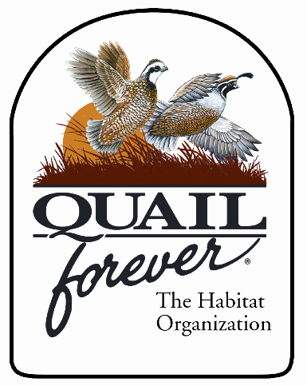
Fall 2018

P.O. Box 6085
Florence, KY 41042
(859)-640-0835
NKYQuailForever@yahoo.com
www.nkyquailforever.com
Northern Kentucky Quail Forever
Chapter # 3198
Watson Jones
(Please contact Watson with any Questions)
Kentucky Bull Elk Permit Auction

July 31, 2026

Avid Hunters,

The Northern Kentucky Quail Forever Chapter has been awarded a KY Commissioners Elk Permit for the Fall 2018 Hunting Season. The money earned from this raffle shall go towards our Habitat Improvement (seed program, habitat maintenance, growth in quail population), Kids Programs (Whistlers Day, youth events, No Child Left Indoors Programs), & the KY Dept. of Fish & Wildlife (Youth Camp Scholarships, Camp Maintenance & Improvement, Habitat Equipment Maintenance). We will be having an Auction to sell the Tag to the highest bidder; the starting bid is $10,000. Minimum bid increments will be set at $500. If you are interested in making a bid, please contact Watson Jones by phone or e-mail above. Be aware that he will call you, if you e-mail, to verify your information. If you place a bid and are outbid, you will be notified and given the chance to make another bid. The deadline for bidding will by 5 PM EST October 1, 2017.

If you have any questions, please contact Watson and he will be happy to help you out. Thank you for your support in the past and good luck to all bidders.

Sincerely,
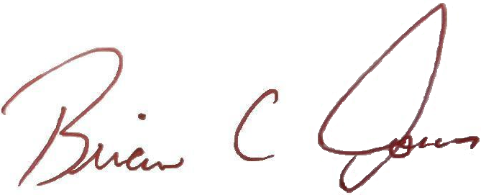
Brian Jones
President

